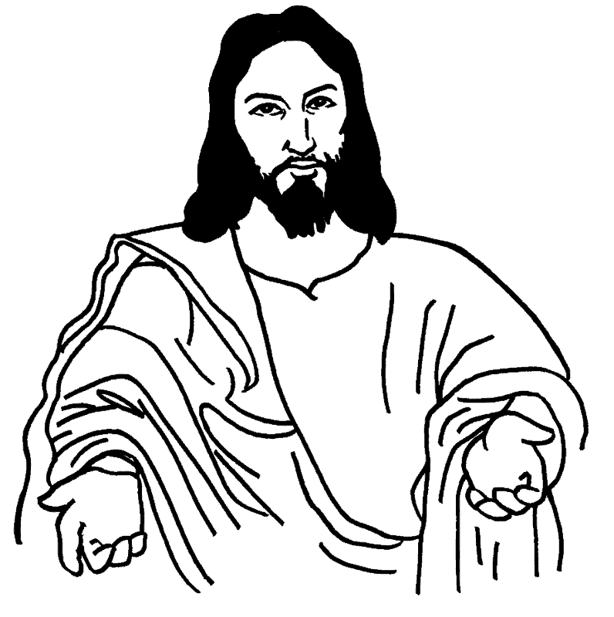
TO THE PARENTS OF OUR CHILDREN, MAY WE SUGGEST…
Relax!!! All are welcome!
Only God owns these seats and you are welcome to sit where you like. Why not sit towards the front where it is easier for your little ones to see and hear what is going on at the Altar. They tire of seeing the backs of others’ heads.
During the service, quietly explain the parts of the Eucharist and the actions of the priest, altar servers, choir etc.
Sing the hymns, pray and voice the responses. Children learn liturgical behaviour by copying you!
If you leave the service with your child, feel free to do so, but please come back. As Jesus said, “Let the children come to me – do not stop them”.
Remember that the way we welcome children in church directly affects the way they respond to the Church, to God, and to one another. Let them know that they are at home in this house of prayer and worship: they are cherished in God’s house.
Please feel free to let your child use the reverse of this card to draw and doodle.

TO MEMBERS OF OUR PARISH
The presence of children is a gift of God to the Church and they are a reminder that our parish is growing.
We are a Christian family who welcomes, cares for and supports children, youngsters, young families and newcomers.
So please welcome our children and give a smile of encouragement to their parents!

TO THE PARENTS OF OUR CHILDREN, MAY WE SUGGEST…
Relax!!! All are welcome!
Only God owns these seats and you are welcome to sit where you like. Why not sit towards the front where it is easier for your little ones to see and hear what is going on at the Altar. They tire of seeing the backs of others’ heads.
During the service, quietly explain the parts of the Eucharist and the actions of the priest, altar servers, choir etc.
Sing the hymns, pray and voice the responses. Children learn liturgical behaviour by copying you!
If you leave the service with your child, feel free to do so, but please come back. As Jesus said, “Let the children come to me – do not stop them”.
Remember that the way we welcome children in church directly affects the way they respond to the Church, to God, and to one another. Let them know that they are at home in this house of prayer and worship: they are cherished in God’s house.
Please feel free to let your child use the reverse of this card to draw and doodle.

TO MEMBERS OF OUR PARISH
The presence of children is a gift of God to the Church and they are a reminder that our parish is growing.
We are a Christian family who welcomes, cares for and supports children, youngsters, young families and newcomers.
So please welcome our children and give a smile of encouragement to their parents!

